2016 FACULTY OF MANAGEMENT – UNIVERSITY OF WARSAW
good/service | time | place
intangible service | season | anywhere

SEMESTER’S THESIS
ECONOMIC ANALYSIS OF
20-MINUTES PACKAGE OF BOEING 737-800 FLIGHT SIMULATOR
Authors:
Marcin Kasprzak (student number 386470)
Marta Socha-Jakubowska (student number 388278)
Natalia Trojakowska (student number 388403)
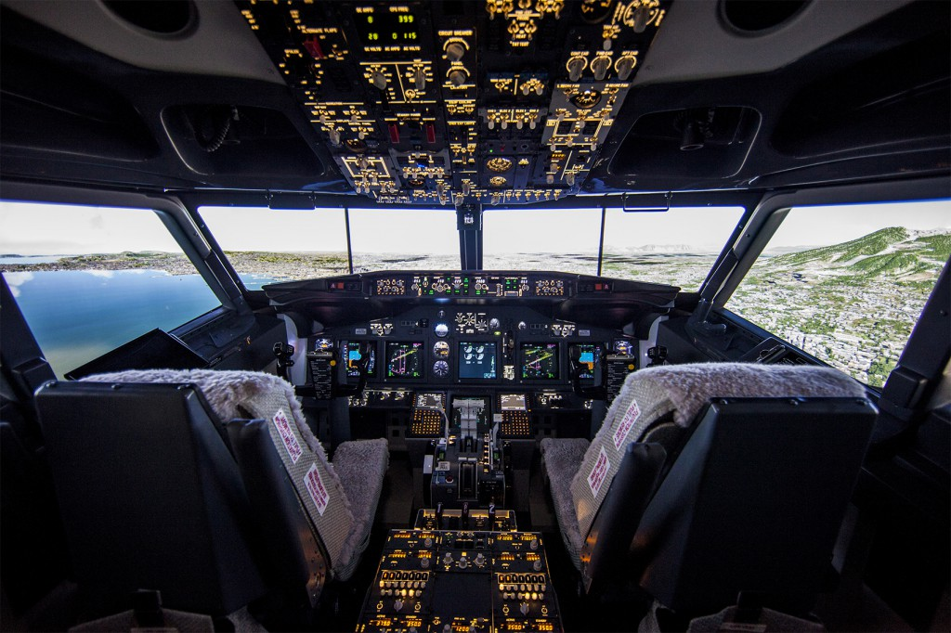

Research problem
Practical verification of how the laws of supply and demand are working on the market of the only one in Poland, professional, full-size Boeing 737-800 aircraft simulator with a resolution of 4K. The cockpit is extremely faithful replica of the real aircraft, where all the controls, switches, displays and levers operate exactly as in reality. The simulator is located at Flyspot, vertical windtunnel,
ul. Wspólna Droga 1 in Mory.

Research goals
- Checking the functioning of law of demand and supply on the market of 20-minutes package of Boeing 737-800 flight simulator.

- It is the part of the student’s researches, which are focused on the analysis of laws of supply and demand in different markets – category intangible service.

Main hypothesis
Prices and quantities available in the market of 20-minutes package of Boeing 737-800 flight simulator depend on the laws of supply and demand.

Detailed Research Hypothesis I
The linear nature of the demand function. $(R^{2}>0.6)$.

Detailed Research Hypothesis II
The linear nature of the supply function. $(R^{2}>0.6)$.
Detailed Research Hypothesis III
Price elasticity of demand function and supply function on the market of 20-minutes package of Boeing 737-800 flight simulator comes to market equilibrium.

Study population
We asked a group of 30 people:
- The age of respondents: 18-28 years old.
- The respondents study or work.
- Residents of Warsaw and surroundings.

The method of the test
- The survey consists one query to the potential buyer:
- How much would you be able to spend on 20-minutes professional, full-size Boeing 737-800 aircraft simulator with a resolution of 4K. The cockpit is extremely faithful replica of the real aircraft, where all the controls, switches, displays and levers operate exactly as in reality?

- Assumptions:
- The prices are given in PLN
- The 20-minutes flight simulator includes:
-a care of an instructor during your stay inside the simulator
-an initial briefing,
-20-minutes flight in a simulator
-a certificate

Date and procedurę of survey
The research was carried out on 19th-22nd of November 2016 - the survey was conducted personally on Szturmowa street in Warsaw . We have selected randomly the group of 15 people who were so kind to answer our questions. Another group of 15 people was asked by us online via “Messenger” App. The information about the supply we got from Flyspot- the only company in Poland that sells this service.

Survey results
Demand’s result:
The survey consists one query to the potential buyer:
How much would you be able to spend on 20-minutes package of professional, full-size Boeing 737-800 aircraft simulator with a resolution of 4K. The cockpit is extremely faithful replica of the real aircraft, where all the controls, switches, displays and levers operate exactly as in reality?

We got 5 averaged results out of 30 results
Price | 92 | 157 | 200 | 269 | 566
Amount of people | 29 | 20 | 18 | 8 | 2

Supply’s results:
We asked the supplier:
How many 20-minutes package of professional, full-size Boeing 737-800 aircraft simulator with a resolution of 4K. The cockpit is extremely faithful replica of the real aircraft, where all the controls, switches, displays and levers operate exactly as in reality would you be able to provide at suggest price?
Price | 92 | 157 | 200 | 269 | 566
Amount of people | 21 | 13 | 10 | 7 | 4

Analysis of collected data:
To analysis the data we collected we use „1PopPod” programme from MMikro Platform.
After collecting all data from the surveys, informations from the company which sells packages of B737-800 flight symulator and data entry we have such results of demand function and supply function

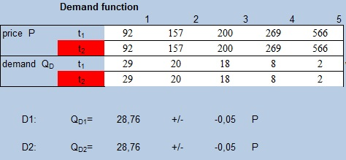
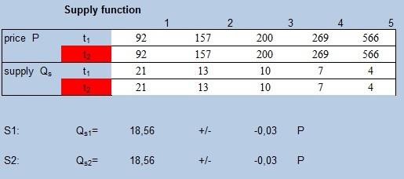

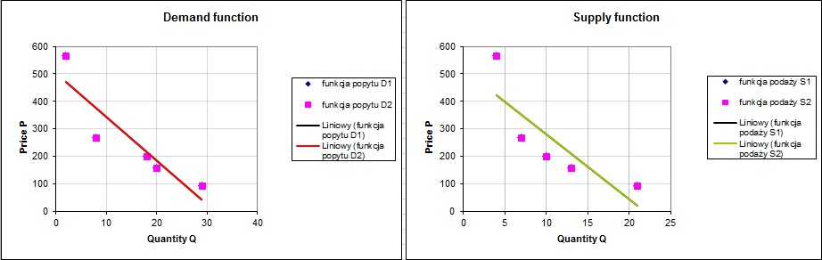
Demand and supply functions:
Q_{D} = 28,76 – 0,05 P
Q_{s} = 18,56 – 0,03 P

It shows us intriguing phenomenon of supply curve with negative line of action which may be caused by having supply’s information from only one supplier that may head to have incomes bigger than fixed costs regardless of production quantity.

Price elasticity of demand and supply
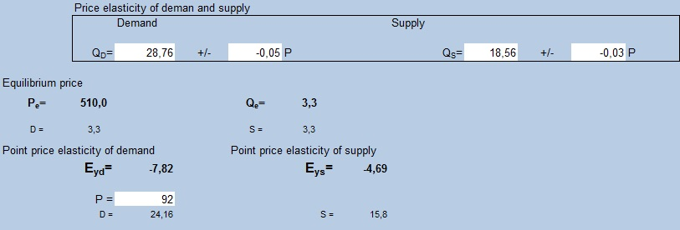It shows that:
Price elasticity of demand at the equilibrium is:
E_{pd} = -7,82
Demand for 20-minutes flight package is highly elastic.
Price elasticity of demand at the equilibrium is:
E_{ps}= -4,69
Demand for 20-minutes flight package is highly elastic.

Analysis of the results:
The equilibrium on market of 20-minutes flight package is highly elastic. For price 451,38 demand elasticity is |E_{pd}|= 7,28. It means that every 1% change in price will cause a 7,38 percentage change in demand and supply is highly elastic |E_{ps}|= 4,69, it means every change in price will cause a percentage change in supply that is 4,69 of the change of price.

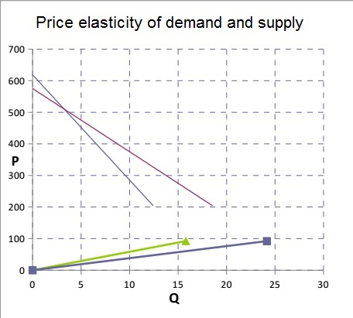

Evaluation of the detailed hypotheses:

Detailed research hypotheses I
Linear character of the demand function
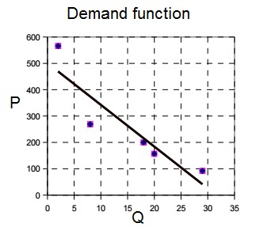
Coefficient of the function-data adaptation: $R^{2}$= 0,9258.
It satisfies the condition that , and therefore this detailed hypothesis is true.

Detailed research hypotheses II
Linear character of the supply function .
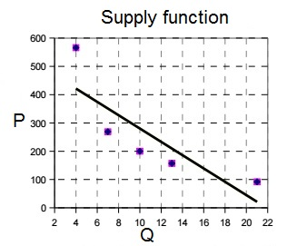
Coefficient of the function-data adaptation is: $R^{2}$ =0,9349
It satisfies the condition that , and therefore this detailed hypothesis is true.

Detailed research hypotheses III
Law of demand and supply for 20-minutes flight package comes to the equilibrium point.
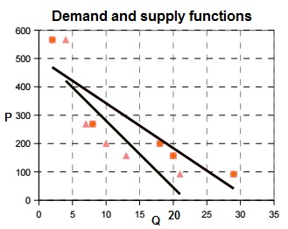
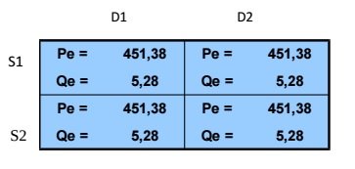
The market is at the equilibrium in point:
P_{E} = 451,38
Q_{E} = 5,28

Conclusion:

After analysing the collected data, we managed to prove all the detailed research hypotheses to be true. Therefore the Main Research Hypothesis:

Prices and quantities available in the market of 20-minutes Boeing 737-800 flight simulator depend on the laws of supply and demand.
The main Hypothesis have been proven and has become a thesis. It is yet another example confirming the existence of the laws of demand and supply.

